

DECISION DRAFT BIOSECURITY POLICY

**Declaring and Categorising Organisms under the BAM Act:**

**Section 11 Permitted and Section 12 Prohibited Organisms**

| **Acknowledgements:** | DAFWA staff (current and previous) have contributed to both the development of earlier versions of this policy and its current form. Special thanks to the Biosecurity Senior Officer’s Group, Biosecurity Council and the previous members of the BAM Act Technical Working Group and the Biosecurity Coordinating Group, |
| --- | --- |
| **Lead Author(s):** | Simone Tuten, Senior Policy Officer Plant Biosecurity |
| **Reviewed by:** | Kirsty Moynihan, Senior Policy Officer Invasive Species  Jamie Finkelstein, Livestock Biosecurity  Mia Carbon, Chief Veterinary Officer Livestock Biosecurity  Bill Trend, Policy Officer Plant Biosecurity  Jessica Bennington, Development Officer Plant Biosecurity  Marc Poole, Research Officer Plant Biosecurity |
| **Approved by:** | DAFWA Executive |
| **Date approved:** | 3 August 2016 |
| **Date for review:** | August 2019 |
| **Person responsible to keep and maintain the policy:** | Senior Policy Officer, Biosecurity and Regulation |
| **Policy number:** | BNR BYPY03 |
| **Version number:** | 1.0 |

TABLE OF CONTENTS

1. BACKGROUND 3

2. PURPOSE AND SCOPE 3

Purpose of this draft biosecurity policy: 3

Scope of this draft biosecurity policy: 3

3. RELEVANT LEGISLATION 4

Permitted organisms 4

Prohibited organisms 4

Control categories 5

Keeping categories 5

4. POLICY CONTEXT 5

National 5

International 6

OIE 6

IPPC 6

5. DECLARING AN ORGANISM AS A SECTION 11 or 12 7

A decision tree representation of the decision points is presented in appendix 2. Identity of the pest 7

Presence or Absence in Western Australia 8

Potential to establish in Western Australia 8

Potential for economic (including environmental) consequences 8

6. CATEGORIES OF PROHIBITED ORGANISMS 9

Control categories 9

Category 1 (C1) – exclusion 9

Category 2 (C2) – eradication 9

No control category 9

Keeping categories 9

Prohibited keeping 9

Restricted keeping 10

7. PROCESS TO DECLARE AN ORGANISM UNDER SECTION 11 OR 12 10

APPENDIX 1: PROCESS TO DECLARE AN ORGANISM (S. 11 OR 12) 12

APPENDIX 2: DECISION TREE 13

BACKGROUND

The *Biosecurity and Agriculture Management Act 2007* (the Act) is Western Australia’s primary biosecurity legislation. One of the objects of this Act is ’*to provide effective biosecurity and agriculture management for the State by providing the means to control the entry, establishment, spread and impact of organisms that may have an adverse effect on*

1. *other organisms, or*
2. *human beings, or*
3. *the environment or part of the environment, or*
4. *agricultural activities, fishing or pearling activities, or related commercial activities, carried on or intended to be carried on, in the State or part of the State.*’

The Act provides this control through the declaration of organisms under different sections of the Act and regulating their entry, movement and management in the state. Requirements on entry, movement and management of an organism depend on its declaration status and control and keeping categories provided for under the Biosecurity and Agriculture Management Regulations 2013 (the Regulations).

The Minister for Agriculture and Food may declare an organism as permitted under section 11, prohibited under section 12 or a declared pest under section 22(2) of the Act. Organisms that are not declared under these three sections of the Act are known as unlisted organisms under section 14 of the Act.

An organism may remain unlisted (s.14) where there is insufficient information to make a decision, or there are other reasons. Policy for determining when an organism should remain unlisted is outside the scope of this document; although, it is important to consider that there are no reporting obligations for unlisted organisms under s.26 of the Act and options to control an unlisted organism should it be detected in Western Australia are limited.

# PURPOSE AND SCOPE

## Purpose of this draft biosecurity policy:

This document provides the overarching assessment criteria and process for declaring an organism to be a permitted organism under section 11 or a prohibited organism under section 12 of the Act. Additionally, the policy provides the overarching assessment criteria and process for assigning prohibited organisms to a keeping and/or control category under regulation 8 of the Regulations. Individual program areas may develop more specific policy to accommodate the needs of those areas which complies with this overarching policy.

## Scope of this draft biosecurity policy:

This document applies to all organisms as defined under section 6 of the Act. It outlines the criteria and process for determining suitability of organisms to be declared under section 11 or 12 of the Act and the categorisation of section 12 organisms into keeping and/or control categories under regulation 8 of the Regulations.

The assessment criteria and process for suitability of organisms to be declared pests under section 22(2) of the Act and associated regulations are outlined in policy BRPY02.

The assessment criteria and process for suitability of permitted organisms to be assigned to the category ‘permit required’ is out of the scope of this policy.

# RELEVANT LEGISLATION

## Permitted organisms

Under section 11(1) of the Act

’*The* *Minister may declare that an organism of a kind specified or described in the declaration is a permitted organism‘*

## Prohibited organisms

Under section 12(1) of the Act

’*The Minister may declare that an organism of a kind specified or described in the declaration is a prohibited organism if there are reasonable grounds for believing that the organism —*

*(a) has or may have an adverse effect on —*

*(i) another organism; or*

*(ii) human beings; or*

*(iii) the environment or part of the environment; or*

*(iv) agricultural activities, fishing or pearling activities, or related commercial activities, carried on, or intended to be carried on, in the State or part of the State;*

*or*

*(b) may have an adverse effect on any of those things if it were present in the State or part of the State, or if it were present in the State or the part in greater numbers or to a greater extent.*’

Prohibited organisms may be assigned into control categories and/or keeping categories. It should be noted that international and national agreements place limitations on the application of section 12.

### Control categories

Regulation 8(1) of the Regulations states that a prohibited organism may be assigned into two categories:

1. *Category 1 (C1) – Exclusion: if in the opinion of the Minister introduction of the prohibited organism into the State or a part of the State should be prevented;*
2. *Category 2 (C2) – Eradication: if in the opinion of the Minister eradication of the prohibited organism from the State or a part of the State is feasible.*

A prohibited organism may be assigned to one or more control categories for the state.

### Keeping categories

Regulation 8(2) of the Regulations states that a prohibited organism may be assigned into two keeping categories:

1. *’Prohibited keeping: if in the opinion of the Minister keeping the prohibited organism in the State or a part of the State should be prohibited except under the authority of a permit to keep -*
   1. *at a zoological park; or*
   2. *at a scientific organisation approved by the Minister; or*
   3. *for scientific, education or government operational purposes;*
2. *Restricted keeping: if in the opinion of the Minister keeping the prohibited organism in the State or a part of the State should be restricted to keeping under the authority of a permit*.’

Under regulation 8(5) if a keeping category is not specified in the declaration, the prohibited organism is taken to have been assigned for the whole of the state to the keeping category designated under regulation (8)(2)(a) (Prohibited keeping).

The area(s) for which the declaration and keeping and/or control categories apply must be specified (regulation 8(4)).

# POLICY CONTEXT

## National

Two national agreements influence this policy. They are the Intergovernmental Agreement on Biosecurity and the Memorandum of Understanding on the Application of Plant and Animal Quarantine Measures. Under these national agreements Western Australia is obliged to comply with the World Trade Organization’s Agreement on the Application of Sanitary and Phytosanitary Measures (SPS Agreement).

## International

The SPS Agreement applies to all sanitary and phytosanitary measures which may, directly or indirectly, affect international trade. Sanitary or phytosanitary measures are measures that are applied to protect animal or plant life or health from risks arising from the entry, establishment or spread of pests, diseases, disease-carrying organisms or disease-causing organisms.

One aim of the SPS Agreement is ’*to harmonize sanitary and phytosanitary measures on as wide a basis as possible, Members shall base their sanitary or phytosanitary measures on international standards, guidelines or recommendations*’.

International standards of relevance to this policy are set by the following standard setting bodies:

* World Organisation for Animal Health[1] (OIE)
* Secretariat of the International Plant Protection Convention (IPPC)

Sanitary or phytosanitary measures which conform to international standards, guidelines or recommendations are presumed to be consistent with the relevant provisions of the SPS Agreement.

### OIE

The OIE relates to animal (including bees) health and zoonosis. Two missions of the OIE relevant to this policy are:

* within its mandate under the WTO SPS Agreement, to safeguard world trade by publishing health standards for international trade in animals and animal products; and
* to improve the framework and resources of national Veterinary Services.

### IPPC

The IPPC relates to plant health. It is ’*an international treaty that aims to secure coordinated, effective action to prevent and to control the introduction and spread of pests of plants and plant products*’ ([ippc.int/en/core-activities/governance/convention-text/](https://www.ippc.int/en/core-activities/governance/convention-text/)).

The IPPC defines a pest as ’*any species, strain or biotype of plant, animal or pathogenic agent injurious to plants or plant products*’. The understanding of the term “pests” under the IPPC includes organisms that are pests because they directly affect cultivated or uncultivated/unmanaged plants, indirectly affect plants, or indirectly affect plants through effects on other organisms.

A subset of pests are quarantine pests, defined as ’*a pest of potential economic importance to the area endangered thereby and not yet present there, or present but not widely distributed and being officially controlled*’.

International Standards for Phytosanitary Measures (ISPM) are developed and adopted under the auspices of the Secretariat for the IPPC.

Of particular relevance to this policy is ISPM 11 which describes the process required to determine if an organism is a quarantine pest. Phytosanitary measures may be applied to quarantine pests (or regulated non-quarantine pests).

# DECLARING AN ORGANISM AS A SECTION 11 or 12

In accordance with the Intergovernmental Agreement on Biosecurity, Western Australia has a policy to comply with the provisions of the SPS Agreement. Under the SPS Agreement Western Australia is required to comply with the international standards established under the IPPC and the OIE. OIE standards are recognised by the World Trade Organization as reference international sanitary rules.

In accordance with the SPS Agreement, a categorisation process is followed to determine if an organism is justified for declaration under section 12 as a prohibited organism. The process complies with ISPM 11 and the OIE Terrestrial Animal Health Code and is comparable to the process used by the Commonwealth Department of Agriculture and Water Resources.

If an organism satisfies the requirements of a quarantine pest as defined by the IPPC, it is appropriate for the organism to be declared a prohibited organism.

The categorisation of a pest as a quarantine pest includes the following elements:

* identity of the pest
* presence or absence in Western Australia
* potential to establish in Western Australia
* potential for economic (including environmental) consequences

**A decision tree representation of the decision points is presented in appendix 2. Identity of the pest**

The organism must be clearly defined to ensure that the categorisation process is being performed on a distinct organism. It should be a distinct taxonomic entity, identified by a valid, accepted name. If it is not possible to clearly define an organism because the causal agent of particular symptoms has not yet been fully identified, then it should be shown to produce consistent symptoms and to be transmissible.

The taxonomic unit for an organism is generally a species. The scientific name should include the genus to which the species belongs, and authority and year of publication (where possible) and common name (where necessary). The declaration of higher or lower taxonomic levels must be justified by scientifically-sound rationale.

## Presence or Absence in Western Australia

An organism that is absent from Western Australia or present but with a limited distribution and under official control (currently or intended to be in the near future) has the potential to be declared to be a prohibited organism provided it satisfies the other criteria of a quarantine pest[2].

Official control is defined by the IPPC as ‘*The active enforcement of mandatory* ***phytosanitary regulations*** *and the application of mandatory* ***phytosanitary procedures*** *with the objective of* ***eradication*** *or* ***containment*** *of* ***quarantine pests*** *or for the management of* ***regulated non-quarantine pests***’ bolded text indicates defined terms under the IPPC.

The OIE defines an official control programme as a program which is approved, and managed or supervised by the Veterinary Authority of a Member Country for the purpose of controlling a vector, pathogen or disease by specific measures applied throughout that Member Country, or within a zone or compartment of that Member Country.

## Potential to establish in Western Australia

The organism’s potential to establish within Western Australia is evaluated and evidence provided to support the conclusion.

An assumption is made that if a host is present in Western Australia then some potential exists for the organism to establish within the state.

Alternatively, potential to establish can be supported by evidence that the ecological/climatic conditions (including those in protected conditions), are suitable for the establishment of the organism and where relevant, vectors are present in the state.

An organism that has potential to establish in Western Australia can be declared a prohibited organism provided it satisfies the other criteria of a quarantine pest.

## Potential for economic (including environmental) consequences

The organism’s potential for economic (including environmental) consequences is evaluated and evidence provided to support the conclusion. There should be clear indications that the pest is likely to have an unacceptable economic impact (including environmental impact) in Western Australia.

An organism that has potential for economic consequences in Western Australia can be declared a prohibited organism, provided it satisfies the other criteria of a quarantine pest.

# CATEGORIES OF PROHIBITED ORGANISMS

Under regulation 8 a prohibited organism may be assigned to control and keeping categories. The area(s) for which the control and/or keeping categories apply must be specified (regulation 8(4)).

## Control categories

Regulation 8(1) of the Regulations states that a prohibited organism may be assigned to one of two control categories either for the whole of the state or a part of the state:

### Category 1 (C1) – exclusion

A prohibited organism is typically assigned to this control category for those parts of the state from which it is absent. This may be the whole of the state. This control category is used if the introduction of the prohibited organism into the specified area is to be prevented.

### Category 2 (C2) – eradication

A prohibited organism may be assigned this control category if its eradication is considered feasible.

For a prohibited organism to be assigned to this control category, it must be subject to planned or current regulatory or control activities. An eradication plan must be in place or under development for the prohibited organism to be categorised in this control category.

### No control category

It is not necessary for a prohibited organism to be assigned to a control category.

## Keeping categories

Regulation 8(2) of the Regulations states that a prohibited organism may be assigned into two keeping categories.

By virtue of regulation 8(5) if a keeping category is not specified in the declaration, the prohibited organism is taken to have been assigned to the prohibited keeping category for the whole of the State.

### Prohibited keeping

A prohibited organism may be assigned to the prohibited keeping category under regulation 8(2)(a). This keeping category is intended for prohibited organisms with the greatest likelihood of establishment or spread or those with significant consequences should they establish or spread in the state or part of the state.

The prohibited organisms may only be kept under the authority of a keeping permit. The keeping permit may specify the conditions for keeping the prohibited organism.

### Restricted keeping

A prohibited organism may be assigned to the restricted keeping category under regulation 8(2)(b). This keeping category is intended for prohibited organisms which do not meet the criteria for the prohibited keeping category and have an unacceptable likelihood of establishment or spread or unacceptable consequences should they establish or spread in the state or part of the state.

The prohibited organisms may only be kept under the authority of a keeping permit. The keeping permit may specify the conditions for keeping the prohibited organism.

# PROCESS TO DECLARE AN ORGANISM UNDER SECTION 11 OR 12

This section outlines the key steps in the process to declare an organism permitted under section 11 or prohibited under section 12, and to amend or revoke an existing declaration.

The process is summarised in Appendix 1.

#### Step 1: Trigger to (re)assess an organism

The process for declaring a proposed permitted organism or proposed prohibited organism and assigning keeping and/or control categories can be initiated either internally or externally. External applications for an amendment to the current declaration status and/or categorisation should be accompanied by sufficient, technically robust information that addresses the relevant criteria outlined in section 5 and 6 of this document for a (re)assessment of the organism status in step 2.

#### Step 2: Assessment of the status of the organism

The four criteria outlined in section 5 of this document will be used to assess, or reassess, the declaration status of the organism.

#### Step 3: Assigning control and/or keeping categories (if applicable)

The criteria outlined in section 6 of this document will be used to determine any appropriate control and/or keeping categories for the organism.

#### Step 4: Consultation with stakeholders

Western Australian government agencies with a potential interest in the declaration and categorisation should be consulted on the proposed status and categories. The key agencies are the Department of Health, the Department of Parks and Wildlife and the Department of Fisheries.

Where the proposed declaration and categorisation may result in increased trade restrictions, the Australian Government Department of Agriculture and Water Resources and other Australian state and territory governments should be consulted. This may occur when a permitted organism is assigned to the category ‘permit required’ (see separate biosecurity policy) or a permitted organism that is intentionally traded is reassessed and proposed to be declared a prohibited organism.

* For matters relating to plants and plant products this consultation is undertaken through the Subcommittee Domestic Quarantine and Market Access.
* For matters relating to animal health this consultation is undertaken through the Animal Health Committee

#### Step 5: Documentation provided to the Minister’s office

Briefing note:

A Ministerial briefing note to be endorsed by the Executive Director (Biosecurity and Regulation) should be prepared. The briefing note includes information on the proposed declaration status (and control and keeping categories if applicable). Evidence to justify the proposed status (and control and keeping categories if applicable) should also be provided.

The briefing note should include a recommendation to the Minister to consult with other Ministers and/or the Biosecurity Council.

Declaration:

A declaration for the Minister’s signature should accompany the briefing note as an attachment.

Note: alternative arrangements could be adopted by programs where powers to declare organisms are delegated

#### Step 6: Declaration and publication

If the Minister supports the proposed declaration status and any assigned control and/or keeping categories, the signed declaration statement will be returned to DAFWA. In accordance with section 157, DAFWA will organise the publication of the declaration in the Government Gazette. The published declaration may include all the information contained in the signed declaration or a notice stating that the declaration has been made and that particulars of the declaration may be obtained from DAFWA’s head office or electronic site.

The gazettal is paid for by the program proposing the declaration to the Minister.

#### Step 8: Notification to stakeholders

Key stakeholders should be notified of the outcome.

# APPENDIX 1: PROCESS TO DECLARE AN ORGANISM (S. 11 OR 12)

**Step 1: Trigger to (re)assess an organism**

Trigger can be an internal or external referral

**Step 2: Assessment of the status of the organism**

The criteria in section 5 of this document will be used to determine the appropriate declaration of an organism as permitted or prohibited under section 11 or 12 of the *Biosecurity and Agriculture Management Act 2007*

**Step 3: Assigning control and/or keeping categories (if applicable)**

The criteria in section 6 of this document will be used to determine any appropriate control and/or keeping category for the organism.

**Step 4: Consultation with stakeholders**

Key stakeholders should be consulted on the proposed status and categories.

**Step 5: Documentation provided to the Minister’s office**

A briefing note and declaration for the Minister’s signature is provided to the Minister

**Step 6: Declaration and publication**

Declarations are published in the Gazette in accordance with section 157 with all information contained in the signed declaration or a notice stating that the declaration is available from DAFWA

**Step 7: Notification to stakeholders**

Key stakeholders should be notified of the outcome.

# APPENDIX 2: DECISION TREE

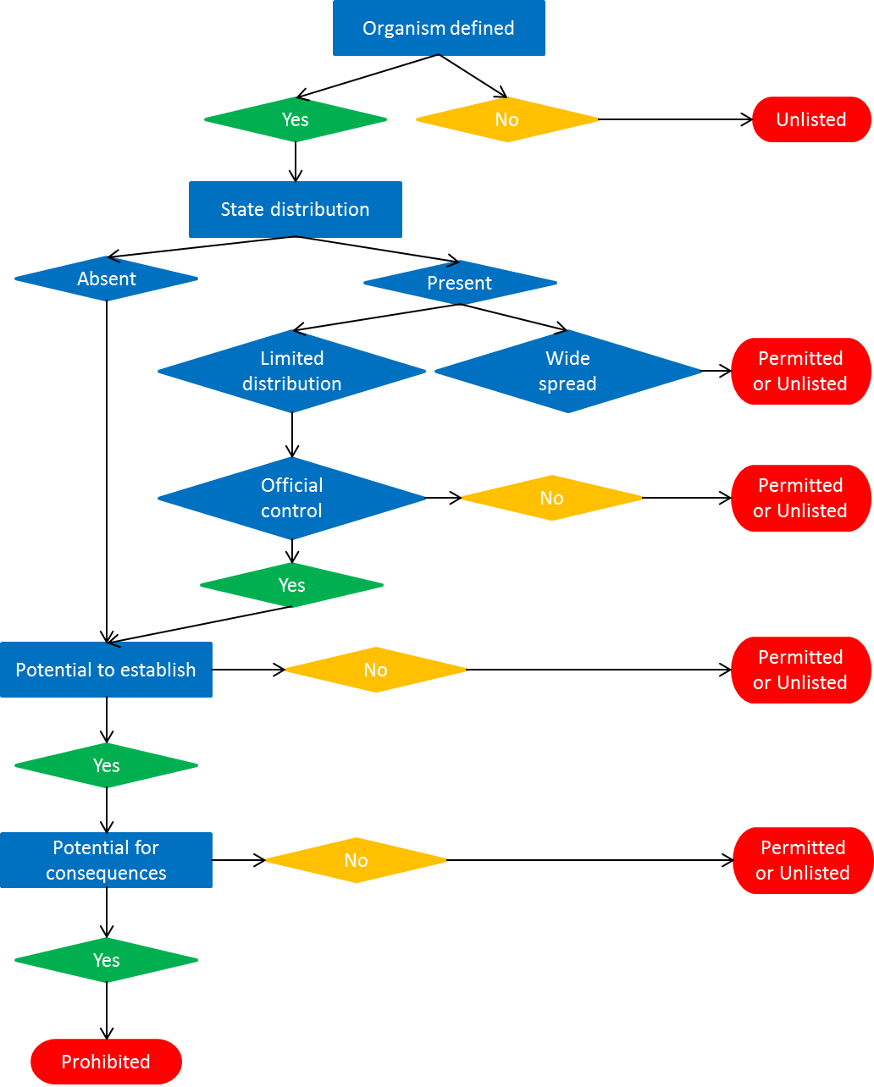

1. Formerly the Office International des Epizooties, the acronym OIE remains in use.
2. For organisms that are present in WA consideration should be given to the organisms suitability for declaration under s.22(2).