DDLS Ehrlichia canis laboratory submission form and shipping guidelines

Ehrlichia canis is a nationally notifiable disease. For suspect E. canis cases, the Department of Primary Industries and Regional Development Diagnostics and Laboratory Services (DDLS) requests submitting veterinarians complete all sections of the:
- DDLS E. canis laboratory submission form (this form) and the
- DDLS animal disease investigation submission form.

E. canis diagnostic test fee determination
Are clinical signs consistent with E. canis? ☐Yes (charge exempt) ☐No (fee payable)

If yes, please specify the clinical signs

Dog and owner details
Dog’s name
Owner’s name
Owner’s residential address | Street and #:
 | Suburb/town: |  | Postcode:
Dog’s current location (if not same as above)
Owner’s phone/mobile number
Owner’s email address
MAX dog number (if known from previous test)
Veterinary consultation and practice details
Date of consultation
Name of veterinary practice
Name of veterinarian
Examination details
Purpose of submission | ☐ For initial diagnosis or rule out of E. canis | ☐ Retest of previously positive dog
Dog’s usual place of residence (see map on page 2). If same as owner’s residential address, write “as above” | Address: _________________________________  ☐Inside area where E. canis is known to be active  ☐Outside area where E. canis is known to be active
Name of town(s) visited by dog in past six months (circle on map on page 2 or identify by name)
Name of town where infection, if present, is likely to have occurred (if unsure, leave blank)

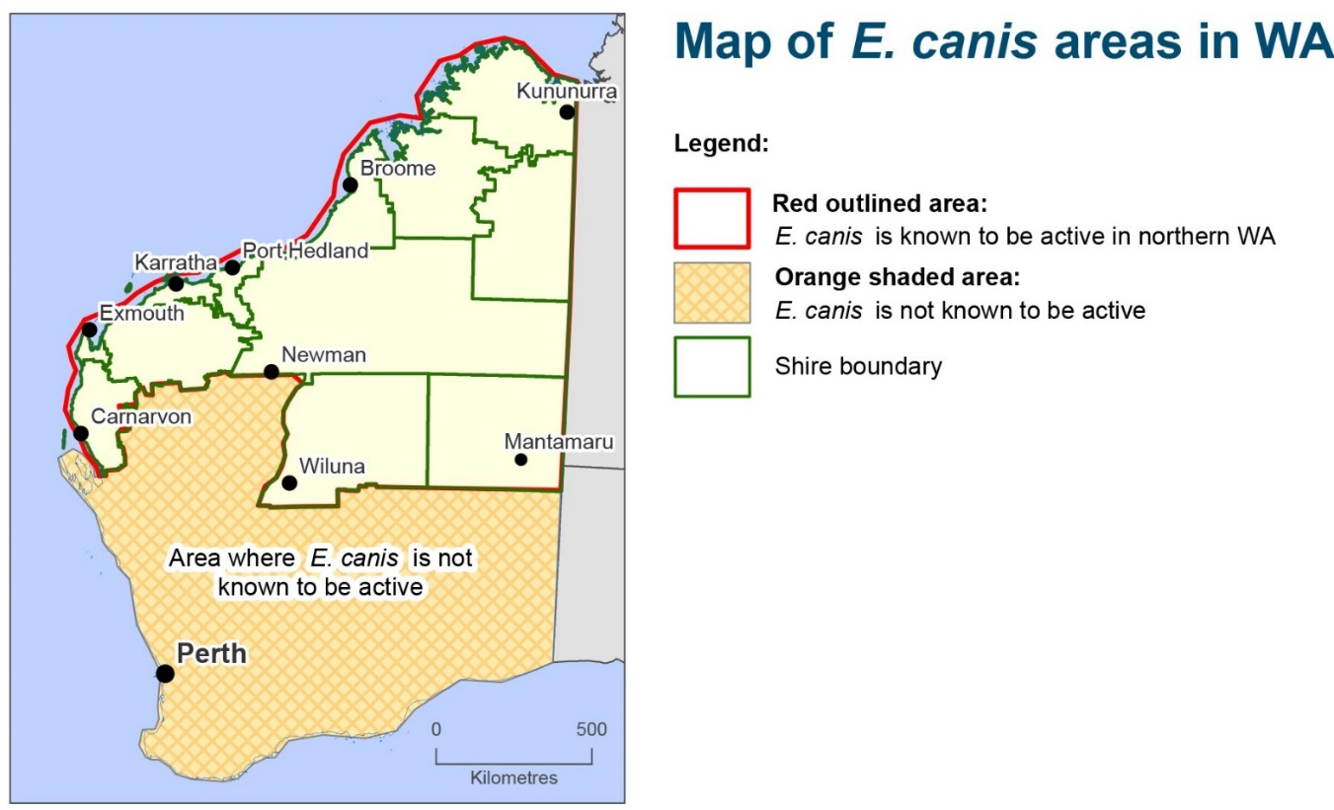
Guidelines for shipping E. canis samples

- Before shipping E. canis samples to DDLS, complete the following forms in full:
  - DDLS E. canis laboratory submission form (this form) – one form for each dog sample submitted
  - DDLS animal disease investigation submission form (list all the samples in the package being sent).
- Place both forms in a sealed plastic bag/envelope and tape them to the outside of the esky.
- Package samples to prevent leakage in transit and to contain and absorb any leakage that could happen.
- Do not send specimens in glass bottles, poor-quality plastic containers, syringes or gloves.
- Pack samples in insulated containers with ice or freezer bricks.
  - Do not pack blood samples in direct contact with ice or freezer bricks.
  - Do not use frozen Ziplock bags as freezer bricks.
- Do not send samples to arrive at the laboratory on the weekend or public holidays, unless prior arrangements with the laboratory have been made.
- Submit samples and the requisite forms to: DDLS Specimen Reception, Department of Primary Industries and Regional Development, 3 Baron-Hay Court, South Perth WA 6151

