Factsheet

Date 20 November 2014

Updates at Department of Agriculture and Food

# The answer my friend is to burn in light wind

It seems ironic that we would spend a growing season killing weeds with a number of herbicide applications only to go and spread the survivors evenly over the paddock at harvest. Many growers in the south west of Western Australia will be burning narrow harvest windrows for the first time this autumn as a first step to including harvest weed seed management in their farming system. It is very important for these windrows to be burnt in the right conditions to achieve high levels of weed seed destruction while minimising fire escapes. Light wind during burning of narrow windrows is critical to fuel the fire all of the way to the soil surface where the majority of weed seeds are.

## Burning temperatures to destroy weed seeds

Kiln studies conducted by Dr Michael Walsh (Australian Herbicide Resistance Initiative, University of Western Australia) determined that temperatures in excess of 400 oC for at least 10 seconds are needed to guarantee the death of ryegrass seed. The same study confirmed that 400 oC for 30 seconds is required to kill wild radish seed within their pod segments.

## Wind speed effects on narrow windrow burning

The high wind speed treatment produced the highest burning temperature and the shortest burning duration. The medium wind speed burnt slightly hotter than the low wind speed treatment (Figure 1). Observations by researchers and growers during burning are that the complete burning of windrows is only achieved in a light wind. The main observation is that burning during still conditions leads to the fire smothering itself and the ash at the soil surface does not smoulder or glow red as it does when there is light wind. This results in a layer of un-burnt trash at the soil surface under the ash.

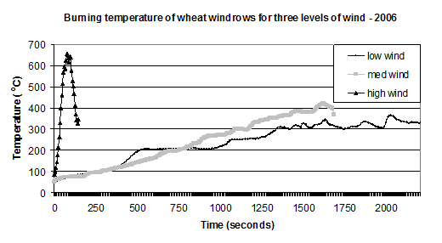

Figure Effect of wind speed on the burning duration and burning temperature at the soil surface of wheat stubble in narrow windrows. Low wind 0 to 5 kph; Medium wind 5 to15 kph; High wind 20 to 45 kph.

## Burning wet windrows

Research by Dr Michael Walsh (AHRI) and Peter Newman (ex-DAFWA, now Planfarm Geraldton) has demonstrated that burning windrows after summer rain does reduce the burning temperature but adequate temperatures to destroy weed seeds are still achieved. Windrows should be allowed to dry for 10 to 14 days after rain prior to burning. Windrows burnt after rainfall events often burn for longer than dry windrows. The rainfall can compact the windrows so light wind during burning is more important than ever to fuel the fire with oxygen to achieve high temperatures at the soil surface.

## What are the long term benefits?

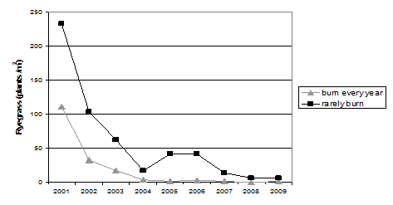

Figure 2 Ryegrass density from focus paddocks of seven growers who burn windrows or tow a chaff cart at harvest every year compared to sixteen growers who rarely practice harvest weed seed management.

These case studies demonstrate that harvest weed seed management is very successful at eroding the seed bank of resistant weeds in cropping situations. Growers who don’t burn windrows or tow a chaff cart have still managed to erode ryegrass seed banks. However, this has been achieved largely through the use of trifluralin (often every year) and they continue to have a residual ryegrass seed bank. Growers who have burnt windrows or towed a chaff cart every year took only three growing seasons to severely erode their ryegrass seed bank and have had six seasons of very low ryegrass numbers since.

# The Art of Burning Narrow Windrows – tips for new players

The art of burning is to burn only that fraction that contains weed seeds and leave the majority of the paddock with residues retained. The following tips have been compiled with the help of growers with extensive experience in windrow burning:

* Consult your local shire / fire warden for burning regulations.
* Always have fire-fighting equipment on hand.
* Harvesting up and back is ideal but not essential.
* Concentrate crop residues into a 600 mm to 700 mm wide windrow using a chute mounted to the rear of the header. Harvest low to minimise the risk of the fire spreading into adjacent stubble.
* To minimise the risk of escapes, commence burning in the late afternoon if permitted. Grower experience has been that most escapes occur while burning in the middle of the day where burning embers blow to adjacent paddocks and bush. Growers in cooler areas of the south west may be able to burn during the day.
* Burn the outside two laps of the paddock first before commencing the remainder of the paddock.
* Burn in light wind. Five to ten kph is ideal. Still conditions do not fuel the fire to the soil surface and are often associated with hot weather where willy willys can pick up burning stubble.
* A light cross wind is regarded by growers as being the ideal direction to fuel the fire to the soil surface.
* It is not necessary to burn on a hot day. The windrow will burn adequately if it is dry and there is light wind.
* Light up windrows every 200 m or so to burn out in reasonable time. If attempting to burn into the wind have a second person with a fire fighter following to extinguish the downwind fire.
* Lupin and Canola windrows can be burnt with the wind as there is low risk of fire escapes, although a light cross-wind is ideal. The biggest risk of fire escape is two year old wheat stubble. If this is a problem, burn into the wind.
* Wheat windrows can be very challenging to contain the fire to the windrow. Wheat crops that yield over 2 to 2.5 t/ha are generally not recommended for windrow burning due to excess bulk. Wheat windrows should be burnt into the wind under cooler conditions e.g. at night if permitted.
* Avoid Barley stubbles. The extra leaf material makes it difficult to contain the fire to the windrow. If you have made barley windrows try a light graze to eat off excess leaf material prior to burning.
* If there is rainfall allow 10 to 14 days for the windrows to dry before burning. If there is a germination of green weeds in the windrow it may be necessary to spray prior to burning.
* Budget on additional fertiliser, particularly potash. Windrow burning is not recommended for fully matched tramline farming systems due to banding of nutrients in the same place each year.
* When harvesting with the chute attached to the rear of the header, if stopping in the crop it is necessary to reverse the header immediately to avoid blockages.

## Contact

* Alexandra Douglas, DAFWA Katanning, (08)98213246, 0455067755 [alex.douglas@agric.wa.gov.au](mailto:alex.douglas@agric.wa.gov.au)

Important disclaimer  
  
The Chief Executive Officer of the Department of Agriculture and Food and the State of Western Australia accept no liability whatsoever by reason of negligence or otherwise arising from the use or release of this information or any part of it.

Copyright © Western Australian Agriculture Authority, 2014