**Farmer wants a life – sheep research open day**

# Muscling out the competition – optimising lean meat yield in your lambs

Steve Connaughton and Rachel O’Reilly, Murdoch University

## Optimising lean meat yield

Nobody wants to spend $40 a kilo on a cut of lamb that turns out to be mostly fat. An increasing amount of fat on a lamb carcass will equate to a lower amount of lean meat for the same carcass weight, which indicates that there has been wasted resources on that lamb, as nobody pays for the excess fat.

Efforts have been made to try and predict how much fat and lean muscle is on a carcass (lean meat yield), so that farmers can get accurate feedback about the makeup of their lamb carcasses, and the consumer can get a consistent product. We currently assess carcass fatness through the grade-rule (GR) site palpation – which is a problematic method, as it is correctly palpated only 30% of the time and has a very low level of precision and accuracy.

Dual Energy X-Ray Absorptiometry (DEXA) is a new method of determining carcass composition, which measures the whole carcass rather than a single point. This method has been demonstrated to be highly accurate, precise, and repeatable. Using a method such as DEXA will result in much better feedback to farmers about their lambs, potentially reducing wasted resources by producing lambs with an optimised lean meat yield. It will also result in a more efficient and consistent lamb supply chain.

## Eating quality and lean meat yield

While yield is an important driver of profits, an increase in yield is often associated with reduced eating quality. Eating quality satisfaction has a strong influence on repeat purchase intent, therefore it is important that a consistent eating experience is provided with every purchase. Given the antagonistic relationship between the two, optimising yield and eating quality independent of one another is not advised. Reasons include:

* Selection for growth rate shifts muscle fibre type from slow twitch (red) to fast twitch (white). Fast twitch muscles tend to be tougher e.g. terminal breed lambs selected for growth rate tend to have tougher meat than merino lambs.
* Intramuscular fat (IMF) % is generally lower in higher yielding animals. Increasing IMF levels has been shown to have a positive association with the sensory traits of tenderness, juiciness, flavour, and overall liking. This has been demonstrated domestically and in Chinese and United States markets.

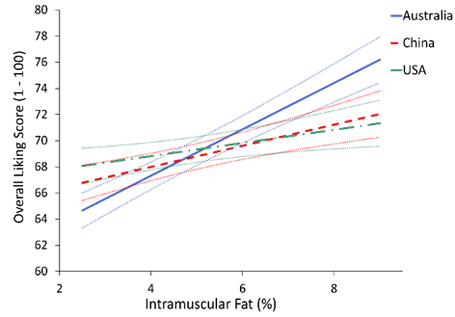

Recent developments in LAMBPLAN terminal eating quality indexes indicate that with a balanced approach to selection, gains can still be made in yield alongside improvements in eating quality. This can be achieved through proactive selection of lean meat yield (LMY %), IMF (%) and shear force nM (SF5) together in breeding programs.