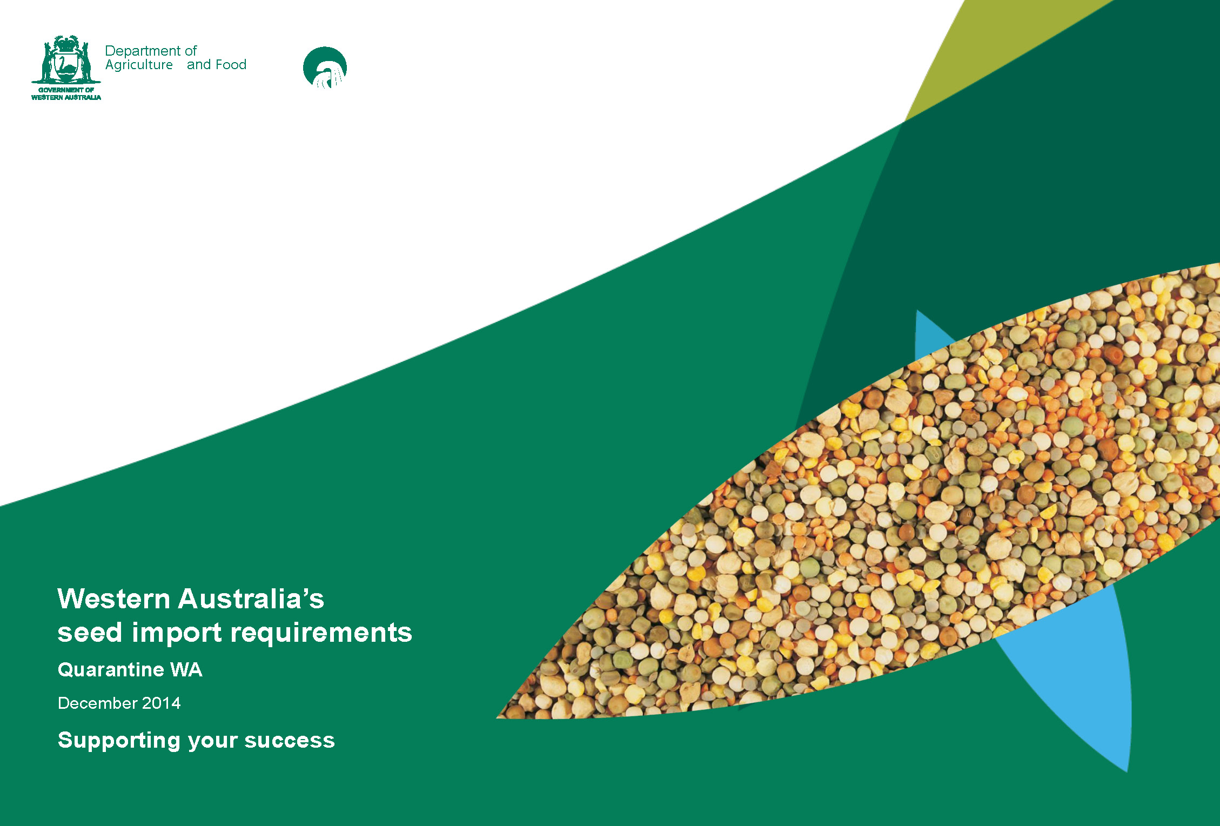

Important disclaimer

The Chief Executive Officer of the Department of Agriculture and Food and the State of Western Australia accept no liability whatsoever by reason of negligence or otherwise arising from the use or release of this information or any part of it.

Copyright © Western Australian Agriculture Authority, 2014

Western Australia’s

seed import requirements

**December 2014**

**Quarantine WA**

**Department of Agriculture and Food Western Australia**

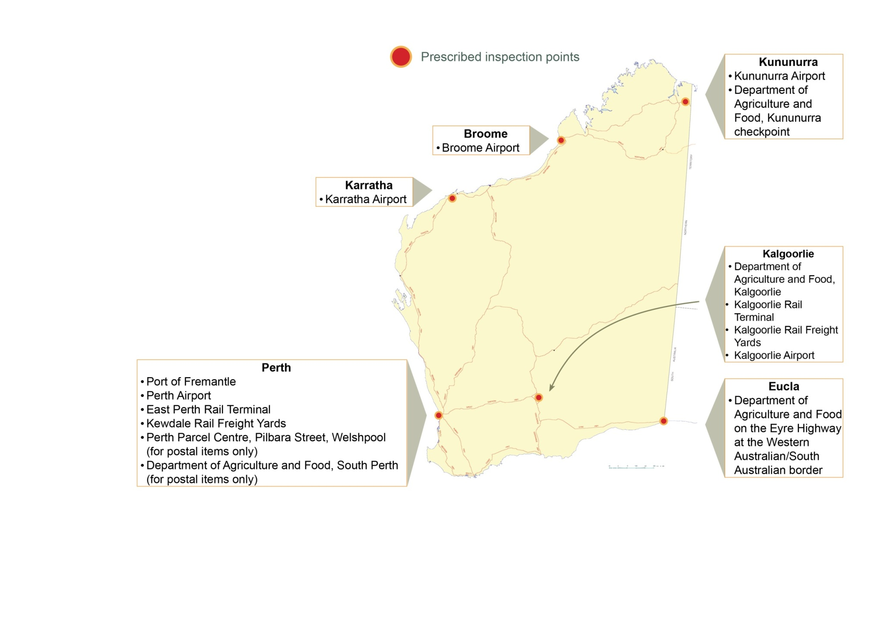

Interstate quarantine inspection services  
contact telephone numbers:

ACT – Compliance and Quarantine Services, +61 (0)2 6207 6376

NSW – Department of Primary Industries, +61 (0)2 6391 3100

NT – Department of Primary Industry and Fisheries, +61 (0)8 8999 2118

QLD – Department of Agriculture, Fisheries and Forestry,   
+61 (0)7 3404 6999

SA – Primary Industries and Regions Australia, +61 (0)8 8207 7900

TAS – Department of Primary Industries, Parks, Water and Environment, +61 (0)3 6165 3777

VIC – Department of Environment and Primary Industries,   
+61 (0)3 8371 3500

# Introduction

Western Australia is free from a number of serious plant pests, diseases and weeds which are present elsewhere in Australia, such as sorghum midge, mango seed weevil, nodding thistle and horsetails. If introduced into Western Australia many of these pests, diseases and weeds would be potentially devastating to agricultural and horticultural industries through loss of production, extra production costs and reduced access to export markets.

It is for these reasons that conditions are in place for the interstate movement of plants and plant products such as fruits, seeds, cuttings and other plant parts. Imported consignments must be presented for inspection to Quarantine WA upon arrival in Western Australia.

Quarantine WA undertakes inspection and surveillance services for the import and export of Quarantine Risk Material (QRM) with the aid of Quarantine detector dogs, X-ray equipment, a container declaration system and random container inspections.

Consignments are inspected by quarantine inspectors at premises approved through Quarantine WA. Quarantine WA objectives are to prevent the introduction and establishment of exotic plants, animal pests and diseases, by effectively regulating the risk pathways associated with interstate movement and trade.

On the pages that follow you will find information on:

* Seed import requirements – these requirements are subject to change. Regular verification of current requirements is recommended, to check seed import requirements please visit the [Quarantine WA Import Requirements Search webpage](https://www.agric.wa.gov.au/qtine/default.asp).
* Approved Seed Testing Laboratories in Australia and overseas.
* Seed mixes and blends.
* Summary of restricted seed types.

Contact telephone numbers for the interstate quarantine inspection services in Australia and WA’s prescribed inspection points are listed on the previous page.

For additional information, please contact: Quarantine WA Seeds Officer

Department of Agriculture and Food, Western Australia  
Level 1, 24 Fricker Road, WA 6105  
Tel: +61 (0)8 9334 1800; Fax: +61 (0)8 9334 1880  
Email: [QWA_SeedsOffice@agric.wa.gov.au](mailto:QWA_SeedsOffice@agric.wa.gov.au)

# Western Australia’s seed import requirements

## Seed must be of a permitted species

To check the Western Australian Organisms List (which includes seed), contact the Quarantine WA Seeds Officer or visit [Biosecurity and agriculture management webpage.](http://www.biosecurity.wa.gov.au/)

On arrival in Western Australia, consignments of seed should be accompanied by an original Seed Analysis Certificate (Bulk Search), identifying the genus and species of the seed and seed contaminants, issued by one of the following:

* A Seed Certification Scheme approved by the Department of Agriculture and Food (or equivalent) in the State or Territory of origin; or
* An inspector authorised by the exporting State or Territory’s quarantine authority certifying that seed has been sampled and analysed by an approved laboratory in accordance with the standards prescribed by the International Seed Testing Association. See the list of the approved seed testing laboratories; or
* A person approved under a quality assurance arrangement. Contact the Quarantine WA Quality Assurance Officer, on telephone  
  +61 (0)8 9334 1800 or fax +61 (0)8 9334 1880.

**Note 1:** Where multiple consignments are sent from one seed lot number, a register based on the original certificate is held with Quarantine WA. This avoids a weed check for each consignment. Such consignments are subject to inspections on arrival into WA – inspection fees apply.

**Note 2:** Certification can be checked prior to export by faxing or emailing certificates to the Quarantine WA Seeds Officer – document inspection fees apply. You will be advised of any problems. If consignments arrive in Western Australia with incorrect or no certification, they are subject to sampling and analysis on arrival. If requirements are not met, the consignment may be subject to re-export, seizure or destruction. Inspection fees and all costs associated with bulk search seed analysis, destruction or re-export of consignment apply.

**Note 3:** Seed Analysis Certificates are valid only for two years from date of issue.

**Note 4:** Treatment Certificates are valid only for 21 days from date of issue.

**Note 5:** Plant Health Certificates must be the original document. Quarantine WA will only accept a copy of original Plant Health Certificate when the issuing Quarantine Inspector faxes or emails the certificate from their office to the Quarantine WA office. The Plant Health Certificate must be endorsed as follows: ‘This is a true and original copy’ and signed and dated by the issuing Inspector.

Note: Plant Health Certificate are only valid for 21 days from date of certification.

## Some seeds must be certified as meeting prescribed pest and/or disease freedom requirements

On arrival in Western Australia the seed must be accompanied by an original Plant Health Certificate issued by an inspector from the exporting State or Territory’s quarantine authority, or a person authorised under an approved quality assurance arrangement, verifying that the seed meets the prescribed pest and disease freedom requirements.

See summary of restricted seed types at pages 13 to 17.

## Seed must be free from pests and diseases of quarantine significance

All consignments are inspected on arrival.

## Seed packaging requirements

All containers must be new and clearly labelled with an identifying lot number, to match the Plant Health Certificate and/or Seed Analysis Certificates.

## Seed must be presented to Quarantine WA on arrival

The prescribed inspection points are the first point of entry into WA. For further information please contact the Seeds Officer. The inspection involves ensuring the above requirements are met and that the consignment details match any certification.

## Overseas import requirements

Seed imports from overseas must also meet the Commonwealth Department of Agriculture, quarantine import requirements.

To contact the Commonwealth Department of Agriculture call +61 (0)8 9334 1555

## Genetically modified seed - Quarantine WA import requirements still apply

Genetically Modified Seed that is sent from interstate sources into Western Australia has to be inspected by Quarantine WA inspectors to ensure that it meets legislated Western Australian import requirements.

Note: Office of the Gene Technology Regulator, Transport Regulations for the movement of Genetically Modified Organisms must be followed, when consigning genetically modified seed into Western Australia, for further information visit their [website](http://www.ogtr.gov.au) or telephone  
1800 181 030.

Contact the Department of Agriculture and Food Western Australia, Executive Officer, Institutional Biosafety Committee,   
telephone +61 (0)8 9363 4682.

# Approved seed testing laboratories in Australia

**AGWEST Plant Laboratories, Department of Agriculture and Food Western Australia**3 Baron-Hay Court, South Perth WA 6151  
Contact: Marcia Vistisen | Tel: +61 (0)8 9368 3844 | Fax: +61 (0)8 9474 2658 | Email: marcia.vistisen@agric.wa.gov.au

| **Seed testing laboratories** | |  |
| --- | --- | --- |
| **Asure Quality** 3-5 Lillee Crescent Tullamarine VIC 3043 Contacts: Monica Slade, Jayde Madden Tel: +61 (0)3 8318 9023 Fax: +61(0)3 8318 9002 Email: monica.slade@asurequality.com | **Futari Consulting (QLD) PTY LTDU** Unit 13, Southgate 489-491 South Street Toowoomba QLD 4350 Contact: Ken Cunliffe Tel: +61 (0)7 4633 3223 Email: futari@futariqld.com.au | **SGS Australia P/L** 59 Bancroft Road Pinkenba QLD 4008 Contact: James Saunders Tel: +61 (0)7 3622 4700 Fax: +61 (0)7 3622 4770 Email: [au.food.agriculture@sgs.com](mailto:au.food.agriculture@sgs.com) |
| **Futari Grain Technology Services** 34 Francis St PO Box 95 Narrabri NSW, 2390 Contact: Leah Petrie Tel: +61 (0)2 6792 4588 Fax: +61 (0)2 6792 4221 Email: futari@futari.com.au | **Seed Services Australia Primary Industries and Regions South Australia** GPO Box 1671 Adelaide SA 5001 Contacts: Peter Smith, Nicholas Coch Tel: +61 (0)8 8303 9549 Fax: +61 (0)8 8303 9508 Email: seeds@ruralsolutions.sa.gov.au | **Queensland Seed Technology Laboratory, University of Queensland** 2 Stewart Street PO: P.O. Box 101 Withcott QLD 4352 Contacts: Toni Romeo Tel: +61 (0)7 4613 9052 Email: seedlab@qstl.com.au |
| **Seed Testing Laboratory Mt Pleasant Tasmanian Department of Primary Industries, Parks, Water and Environment** 165 Westbury Road Prospect TAS 7250 Contact: Rachel Harvey Tel: +61 (0)3 6777 2146 Fax: +61 (0)3 6344 4961 Email: [rachel.harvey@dpipwe.tas.gov.au](mailto:rachel.harvey@dpipwe.tas.gov.au) | No data | No data |

# Approved seed testing laboratories outside Australia

**AsureQuality Lincoln Ltd**

Lincoln University

PO Box 6

Lincoln

New Zealand 7647

**AsureQuality New Zealand Ltd**

National Seed Laboratory

Tennet Drive , PO Box 609

Palmerston North

New Zealand 4440

**New Zealand SeedLab Ltd**

PO Box 16101

Christchurch

New Zealand 8441

**Seed Tech Services**

Massey University

Private Bag 11222

Palmerston North

New Zealand 4442

**Only orange ISTA certificates issued by the below seed testing laboratories are accepted.**

| Testing laboratory | Address | Country |
| --- | --- | --- |
| Bejo Zaden B.V. | Trambaan 1, 1749 CZ Warmenhuizen, Netherlands | NETHERLANDS |
| Enza Zaden Beheer B.V. | Haling 1 E, 1602 DB, Enkhuizen, Netherlands | NETHERLANDS |
| Monsanto Holland B.V. | Leeuwenhoekweg 52, NL – 2661 CZ Bergschenhoek, Netherlands | NETHERLANDS |
| Rijk Zwaan Production B.V. | Burgemeester Crezeelaan 40, 2678 KX De Lier, Netherlands | NETHERLANDS |
| Agri Seed Testing, Inc. | 1930 Davcor Court SE Salem, Oregon, 97302 | USA |
| Oregon State University Seed Laboratory | 3291 Campus Way Corvallis, Oregon, 97331 | USA |
| Seminis, Inc. | 2700 Camino Del Sol Oxnard, California, 903030 | USA |
| SGS Mid-West Seed Services, Inc. | 236 32nd Avenue Brookings, South Dakota, 57006 | USA |
| 20/20 Seed Labs, Inc. | 507-11th Avenue Nisku, AB Canada T9E7N5 | CANADA |
| Laboratorio di Ricerca c Analisi Sementi-LaRAS | DiSTA-Universitadi Bologna Via Fanin, 40 40127 Bologna | ITALY |

# Seed mixes

Seed mixes “that do not contain restricted seeds” require a Seed Analysis Certificate to accompany the consignment (see approved seed laboratories listings on pages 9 and 10).

Seed mixes “containing restricted seeds” are also to be accompanied by a valid Plant Heath Certificate, for restricted seeds (see pages 13 to 17).

All seed mixes are not subject to International Seed Testing Association requirements for bulk search weights. Instead Quarantine WA (QWA), utilises world best practise by following the Association of Official Seed Analysts (AOSA), method as outlined below:

The seed supplier must advise the sampler of the components of the mixture and the relative percentage of each type of seed in the mix.

* This information must be supplied to the seed testing laboratory together with the sample, which must be drawn by an accredited sampler.
* It is recommended that the sample provided to the laboratory is at least 1 kg to ensure a sufficient sample is drawn.
* The Bulk Search Weight (BSW) of the mixture is to be calculated by allocating a corresponding proportion of the scheduled BSW for each seed type to the total BSW for the sample (see example below).
* The seed testing laboratory shall annotate the component percentages as advised by the client on the Seed Analysis Certificate so QWA can verify the BSW was sufficient, together with a listing of non-component seeds found (if any).

See example below:

| Components (as advised by client) | % component (as advised by client) | ISTA BSW | Total BSW |
| --- | --- | --- | --- |
| *Phalaris canariensis* | 24% | 200g | 48g |
| *Panicum miliaceum* | 26% | 150g | 39g |
| *Carthamus tinctorius* | 25% | 900g | 225g |
| *Helianthus annuus* | 25% | 1000g | 250g |
|  |  | **Total BSW** | **562g** |

# Seed mixes (continued)

Maximum lot size of mixed seed consignments.

The maximum lot size for a mixed seed consignment shall be determined by the ISTA maximum lot size of each component apportioned to correspond with the percentage of the mixture represented by that component.

See example below:

| Components (as advised by client) | % component (as advised by client) | ISTA max lot size (kgs) | Lot Size (% component x ISTA) |
| --- | --- | --- | --- |
| *Phalaris canariensis* | 24% | 10 000 | 2 400kg |
| *Panicum miliaceum* | 26% | 10 000 | 2 600kg |
| *Carthamus tinctorius* | 25% | 25 000 | 6 250kg |
| *Helianthus annuus* | 25% | 25 000 | 6 250kg |
|  |  | **Maximum lot size** | **17 500kg** |

**Additional requirements for seed with altered lot codes or other descriptions, such as coated or blended seeds:**

* A statutory declaration is to be made on the exporting company’s letterhead by a responsible person of that company containing the following information:
* Detail of original lot code and seed name/type.
* Detail of new lot code and seed name/type.
* For blends: details of each component in the seed mix/blend including individual lot codes and names and percentages.
* For coated seed: details of the increase in lot weight (if any).
* Name of person making the declaration, their position and signature plus date of issue.

# Summary of restricted seed types

Conditions of entry into Western Australia - Under the Biosecurity and Agriculture Management Regulations 2013

| Commodity | Seed type (pest/disease risk) | Conditions* |
| --- | --- | --- |
| **Corn, maize and sweetcorn** **\*\*** (*Zea mays*) | **Seed for planting** (Boil smut – *Ustilaggo maydis*) | To be certified by the Department of Primary Industry in the State or Territory of origin that:  a. the seed is from an area which is free from boil smut; or  b. the seed has been treated with Vitavax 200FF® at the rate of 500 mL/100 kg of seed. |
| **Cotton** **\*\*** (*Gossypium* spp.) | **Seed** (Verticillium wilts - *Verticillium dahliae* and *V. alboatrum*) | To be certified as having been acid de-linted to the satisfaction of an inspector. |
| **Lucerne** **\*\*** (*Medicago sativa*) | **Seed** (Bacterial wilt – *Clavibacter michiganense* ssp. *insidiosum*) | **Grown in South Australia –** to be accompanied by an original Plant Health Certificate issued by Primary Industries and Regions South Australia declaring the consignment to be either:  1. from a property that has been inspected and found free from bacterial wilt; or  2. PCR (polymerase chain reaction) tested and found free from bacterial wilt.  **Note** – property inspection and PCR testing is permitted subject to South Australia maintaining bacterial wilt area freedom requirements.  **South Australian lucerne seed coated in other States or in South Australia** where coating of seed from other states occur, approval by Department of Agriculture and Food WA Policy Group must be granted prior to sending to WA.  **Grown in State or Territory other than South Australia – prohibited**. |
| **Mango** **\*\*** (*Mangifera indica*) | **Seed** (Mango seed weevil – *Sternochaetus mangiferae*) | To be certified as  **a**. grown in a State, Territory or country where mango seed weevil is not known to occur; or  **b**. complying with an import protocol approved by the Department of Agriculture and Food WA. |
| **Myrtaceae \*\***  Family for example including but not limited to e.g. Eucalyptus, Callistemon, Leptospermum | **Seed** (Myrtle rust) | **Grown in Tasmania** – to be accompanied by an original Plant Health Certificate issued by Department of Primary Industries, Parks, Water and Environment declaring the consignment as grown and packed in Tasmania.  **Grown in State or Territory other than Tasmania – prohibited.** |
| **Palm** **\*\*** (Arecaceae - all genera) | (Fruit flies) | Palm seed with a fleshy pericarp may be subject to fruit fly requirements. |
| **Rice\*\***  (*Oryza* sp.) | **Unmilled** (Warehouse beetle – *Trogoderma variabile*) | To be certified that  a. the rice was produced and packed in an area that is free from the pest warehouse beetle; or  b. the rice and associated bulk containers including pallets, crates and bins have, within five days prior to dispatch, been fumigated with methyl bromide at the rate of 48 g/m3 at 20°C for 24 hours, and any associated railway wagons have been treated within three days prior to loading with either Reldan, Alfacron or Actellic at a rate of 1 g active ingredient per square metre. |
| **Soybean\*\*** (*Glycine max*) | **Seed for planting** (Black leaf blight -Arkoola nigra) (Stem rot -Phytophthora megasperma f.sp. glycines) | To be certified as:  a. grown in a area where black leaf blight has not been recorded; and  b. treated with 35% metalaxyl at the rate of 300 g/100 kg of seed. |
| **Sugar cane\*\*** (*Saccharum officinarum*) | **Seed** (Ratoon stunting virus; Sugar cane Fiji disease) | Sugar cane plants or parts of plants (including seed) are prohibited from entering Western Australia from other parts of Australia without the prior approval of the Director General. |
| **Sorghum** **\*\*** (*Sorghum* spp.) | **Seed** (Sorghum midge - *Contarina sorghicola*)  General diseases (Rust - *Puccinia purpurea*) (Smut - *Sporisorium reilianum*) | 1. To be certified that the seed has been fumigated with:  a. phosphine in a sealed enclosure at 1.5 g/m3:  i. for seven days at above 25°C; or  ii. for 10 days at 15°C–25°C; or  b. methyl bromide for two hours in a sealed enclosure at one of the following rates:  i. 24 g/m3 at 26°C–31.9°C;  ii. 32 g/m3 at 21°C–25.9°C;  iii. 40 g/m3 at 15°C–20.9°C;  iv. 48 g/m3 at 10°C–14.9°C; or  **c**. irradiated at minimum dose of KGy 25.0 and accompanied by a pre-shipment certificate of irradiation.  **Note**: Seed to contain less than one per cent by weight of chaff consisting of pieces of vegetative parts of plants other than seed or seed fragments.  2. Sorghum seed for sowing to be certified by an officer from the exporting State, Territory or country’s quarantine authority as:  a. dipped in 2% available chlorine for five minutes; or  b. dusted with Thiram 80% at the rate of 200 g/100 kg of seed. |
| **Walnuts \*\*** (*Juglans* spp.) | **In the shell** (Codling moth -*Cydia pomonella*) | To be certified as fumigated with methyl bromide at 32 g/m3 at 20°C for 24 hours. |

**\*\* Important note**: To be certified by an Officer from the exporting State or Territory’s quarantine or agricultural authority